

P. Swetha Nagasri

Dadi Teja Sadwika

2520030536
CSE
CO1 – Trees and Balanced Trees

Case Study Topic: RetailMind – Smart Retail Product Management System (CO1 Focus: Binary Search Trees & AVL Trees)

Work Done Summary:
RetailMind is a smart retail management system developed to organize and manage product records efficiently. The system uses a Binary Search Tree (BST) to store and search product information based on product IDs. To maintain balanced search performance, an AVL Tree is implemented. AVL rotations automatically balance the tree after insertions and deletions, reducing search time and improving overall system efficiency. The system helps retail stores manage products quickly and accurately.

Implementation Details:
- Product records are stored using a Binary Search Tree.
- Each product is identified using a unique product ID.
- BST supports insertion, deletion, and searching operations.
- AVL Tree maintains a balanced structure after updates.
- Left and Right Rotations are used when imbalance occurs.
- Search operations become faster due to balanced tree height.
- Product information can be retrieved efficiently.
- The system improves retail inventory management performance.

Output:
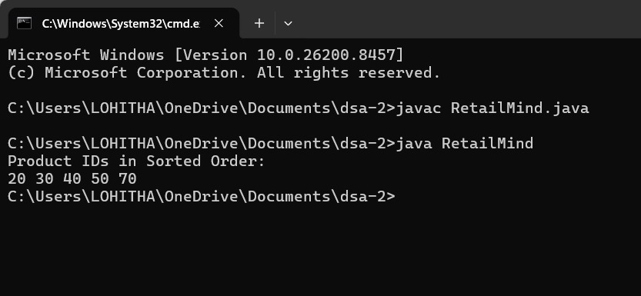
RetailMind efficiently manages product information using Binary Search Trees and AVL Trees. BST enables organized storage and retrieval of product records, while AVL Trees maintain balance and improve search efficiency. The system reduces retrieval time and supports effective retail inventory management.

Github link:

